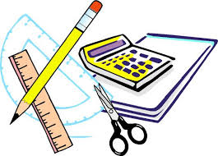
6th Grade Language Arts
Back to School
Supply List

We want you to be the BEST student possible! That success starts with supplies that will make your school year start right! The following lists of supplies are what we would like each student to have for our 6th grade English classes to have on the first day! AVID is offering a pre-made binder for $20 that includes most, but not all of the supplies.

Student Materials
- Binder at least 2” – 3”
- Planner ($6.00)
- 5 dividers (not 8, FIVE!)
- Pencil pouch (not needed if pouch is part of binder)
- GEL highlighters (other highlighters will bleed through our new workbooks)
- Pencils (mechanical pencils preferred)
- Eraser
- Colored pencils
- Glue stick
- Binder paper
- One COMPOSITION notebook (Mead or Staples) MUST BE THREADED not glued!
- 2 Book covers for school-issued textbooks (Science & Social Studies)

If you are interested in donating items to our classroom we have created a classroom wish list. Any donations are GREATLY appreciated.

Classroom Wish list
- Kleenex
- Composition Notebooks
- Colored pencils
- Glue sticks
- GEL Highlighters
- Erasers
- Ziplock Bags
- Post it Notes

We look forward to a terrific year! Have fun tonight and we’ll see you Thursday!

