Kaseberg
5th Grade
Date: Week of August 19, 2019
Mr. Tapia: STapia@rcsdk8.org

Mojo of the Week week for 8/8  Congratulations to Joshua Hernandez for being chosen as Mojo of the Week. He shows a growth mindset by working hard and staying on task. Joshua was very polite and helpful the first week. Keep up the hard work!  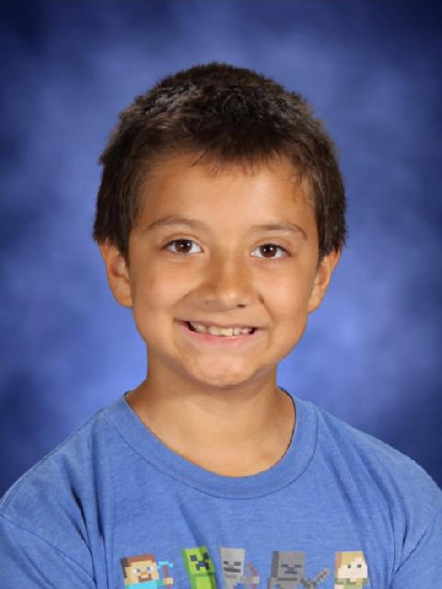 | Mojo of the Week for 8/19  Congratulations to Kelvin Bui. He really exemplifies the idea of growth mindset. Kelvin shows his work inmath and keeps going even when he struggles. He listens and tries, and embraces the struggle that is learning.  Keep up the hard work!  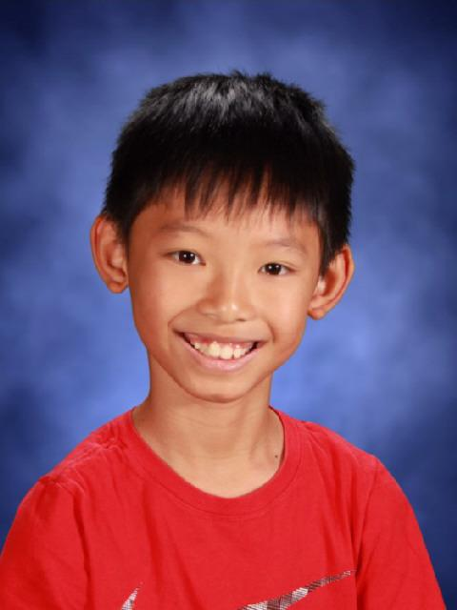

Standards being taught:
Reading: Identify Main Idea and Key Details and Analyze Text Structure
Writing: Generating ideas for personal narratives
Social studies: Early Native Americans
Science: Introduction to Chemistry
Math: Look for patterns in the MathBoard fraction bars, and discuss how unit fractions are used to build other fractions.

Ways you can help your child at home:
Encourage your child to practice a small amount of math each day for an overall large improvement.
In writing we are focusing on the personal narratives and the writing process;
- Generate Ideas
- Flash draft
- Revise
- Edit
- Publish

Dates to remember:
8-22: Student Council Meeting. Students must attend if they plan on being a part of Student Council. The meeting is at the beginning of lunch recess in Room 20.

Back to School Night Highlights:
- Homework in math/ Parents notified via Class Dojo when homework goes home
- ELA homework sometimes as necessary
- Read every night for 20 minutes
- Behavior / one warning / Accoutability card completed by the student and brought home to have signed by parent / referral last resort
- Communication with teacher / email stapia@rcsdk8.org / Class Dojo / Call school and leave message
- Growth Mindset for the students https://www.mindsetworks.com/science/

