Kaseberg
5th Grade
Date: Week of Oct. 8, 2018
Mr. Tapia: STapia@rcsdk8.org
Mrs. Adams: TAdams@rcsdk8.org

Mojo of the Week room 16  Congratulations to Steven Canlas! He has shown growth mindset by persevering when given challenging tasks in class. Steven’s attitude of not giving up is a model for other students to follow. Keep up the great effort in class!  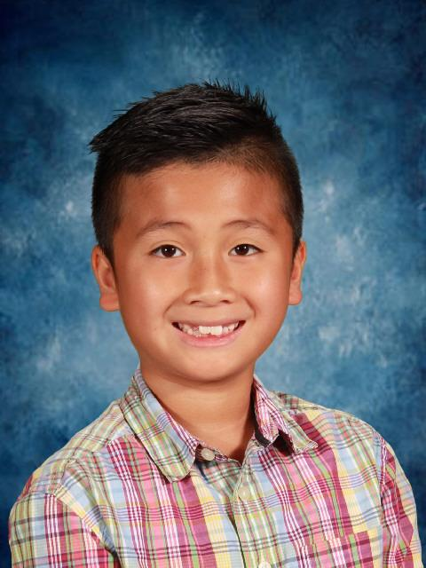 | Mojo of the Week room 17  Congratulations to PJ Wiltz! He shows growth mindset through his absolute joy in embracing challenges. He consistently displays an eager and open attitude towards learning, and enthusiasm for sharing his ideas.  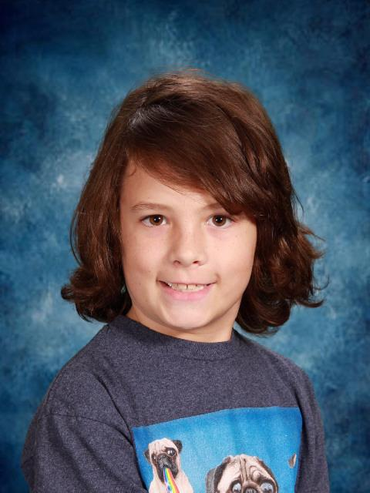

Standards being taught:
Reading: Analyze Evidence: Primary Sources
Writing: Plan and Organize an Opinion Essay
Social studies: Life in the Colonies
Science: We are finishing up with physical change and using texts to determine the best ways to understand informational text. We will be moving to physical change.
Math: Decimals decimals decimals! We are starting with reviewing what is a decimals, relating them to fractions, and reviewing place value.
Ways you can help your child at home:
- Have them go over their check ins with you and explain how to do one of the problems
- Have them go onto IXL for additional practice.
- The kids ABSOLUTELY need to know their place values!! One-million to thousandths.
- Have your child show you their reading journal entry for the week

Dates to remember:
Oct. 9: ukelele starts
Oct. 11: assembly for responsibility winners
Oct. 12: book orders due; dress like teacher day
Oct. 17: SC; B street permission slips and money due by 3:00
Oct. 19: B St. trip; end box top collects for root beer float winners
Oct. 31: parade at 9:00; pumpkin carving with buddies; class party
Nov. 1-2: no school for kids
Nov. 5-9: mini mini days for parent conferences
Nov. 12: no school (Veterans Day)
Nov. 14: school performance of musical
Nov. 15: night performance of musical
Nov. 19-23: Thanksgiving vacation
Nov. 30: Santa’s Helpers

