Hand Ball Study Guide Name:
Where did team handball originate?  _______________  How many points is a goal?  _______________  Handball is a combination of soccer, basketball and ________?  _______________  How many steps can you take with the ball before and after dribbling?  _______________  How long can you hold the ball?  _______________  How long may I dribble?  _______________  Who can step into the goalie crease?  _________________  It is a ____________  If a player is fouled while trying to pass to a teammate.  A penalty shot is taken from the  ___________ line.  Can a defensive player block a throw or pass?  _______________  Circle the type of pass that is least effective?  - Overhand  - Push  - Two handed  - Side arm  How far away is the defense during a free-throw?  _________________ | History of the Game  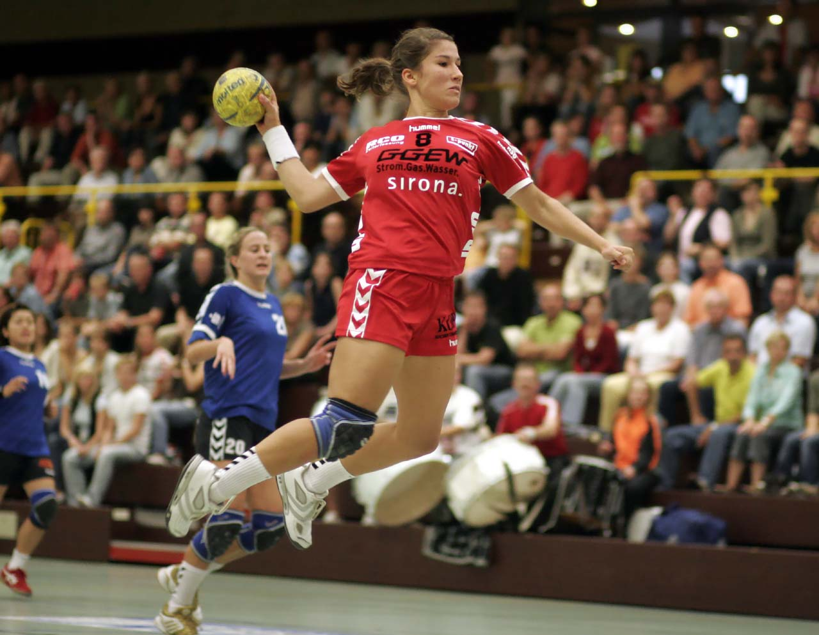  Team handball originated in Europe in the early 1900’s. The game itself is a combination of soccer, basketball and hockey. Even though it is not well known to Americans, it has been an Olympic event since 1972.  Object of the Game  Players will move the ball down the court and try to score by throwing the ball past the goalkeeper into the net. Each goal is worth 1 point. Team Handball is a fast paced action packed game and typical scores run in the mid twenties.  Basic Rules  - Start game or after a goal with a “throw off”. All players must be on their side of the ball and the pass must be a lateral or backward pass.  - Offensive players may  - Take 3 steps with the ball before dribbling.  - Hold the ball for 3 seconds while NOT dribbling.  - Take 3 steps with the ball after dribbling.  - No one can be in the goal area except goalie.  - Defense cannot grab or knock the ball from opponents hands. They can steal balls that are being dribbled and block shots and/or passes..  - Players are not allowed to kick the ball (goalies may use feet).  - Offensive players may not enter the goalie crease at anytime. Follow through steps after shots will not count.  - Defensive players may not go into crease.  - PE rule: must make three passes before shooting. Goalie pass counts as one.  - Offensive team may not pass back to the goalie.  Penalties  A free throw is given for a foul (hitting the ball or arm of the offensive player) or rule violation (double dribble, traveling, goalie pass back, etc.) at the exact spot it took place. The exception would be if the foul occurred inside the 9 meter arc, then the offense must take the free throw outside the 9 meter arc. Defense must be 3 meters away (4 large steps) and thrower may make a pass or shot on goal.  A penalty shot is given for a foul that occurs during the act of shooting. Any foul/violation that destroys the chance of the player scoring. This may be fouling/hitting the shooter or stepping into the goalie crease to defend the shooter.  Strategies  Offensive  - Maintain possession of the ball by making good passes.  - Attack the goal by moving to an open space  - Do not have all your players going for the ball at the same time.  - Triangle offense, fill the lane or move to the open space.  - Take as many shots a possible.  - Vary your shots  Defensive  - Stay between the goal and the offensive players.  - Defend your space by marking your person on defense (man to man defense).  - Or play “Zone” defense by creating a wall around the 6 meter arc.  - Goalies square to shooters and cut down the angle when defending your net. Goalies keep hands up and try to block the ball, not always try to catch the ball. Goalies may also use feet to block shots.  Skills  - Passing/Shooting:  One handed throws-- overhand, side-arm, and shovel/push passes are most effective. Two handed “basketball” passes are not recommended. Shooting: one handed and bounce shots will be more effective.  - Catching: Keep eyes focused ball with fingers up and spread. Make a “W” with fingers for a two-handed catch. Always “give” (soft hands) a little when catching two-handed or one handed. One handed catch is difficult but a high level skill.  - Dribbling: use finger tips to control ball. Try not to over dribble--the ball is small and you risk losing control.  - Steps: Use your three steps before and after drbbling wisely. Players may move a long distance with only one dribble. This will allow for better shooting angles.  Court Diagram:  goal  6 meter goalie crease  7 meter penalty line

