Official
Crestmont School

Handbook

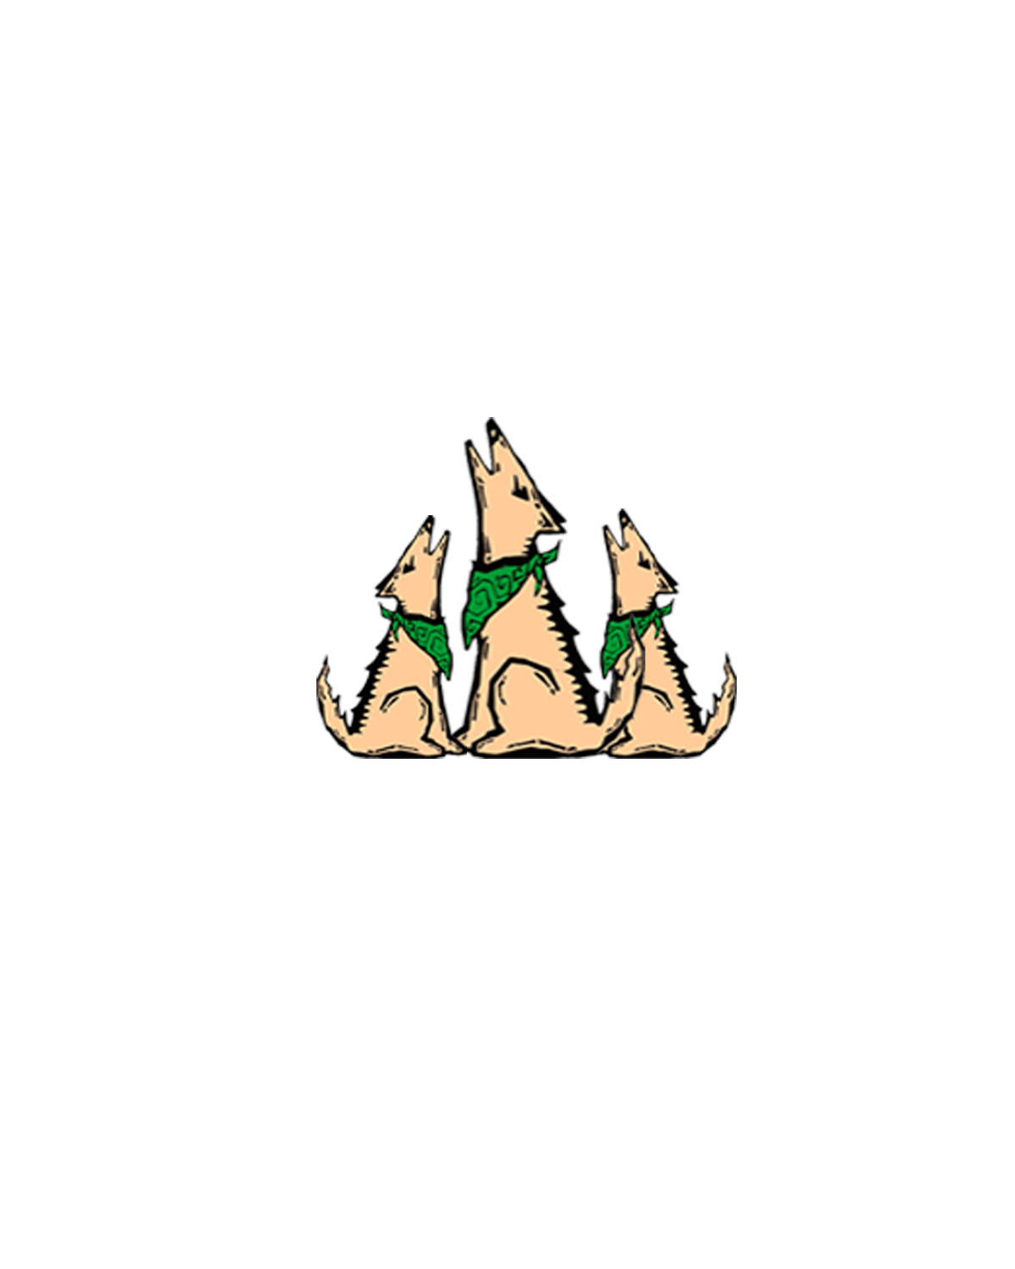

2017-2018

Edition

TABLE OF CONTENTS

PRINCIPAL’S WELCOME . . . . . . . 2
BELL SCHEDULES . . . . . . . . 3-4
STUDENT ARRIVAL . . . . . . . . 4
ABSENCE/TARDINESS . . . . . . . . 4
HOMEWORK ASSIGNMENTS . . . . . . . 5
CYBER BULLYING . . . . . . . . 5
DENTAL/DOCTOR APPOINTMENTS . . . . . . 5
HOT LUNCH & BREAKFAST INFORMATION . . . . . 5-6
CLASSROOM CELEBRATION TREATS . . . . . . . 6
ILLNESS . . . . . . . . . 6
MEDICATION ON CAMPUS . . . . . . . 6
OBSERVER ETIQUETTE . . . . . . . 7
CLASSROOM INTERRUPTIONS . . . . . . . 7
POSITIVE BEHAVIOR SUPPORT PROGRAM / LIFESKILLS . . . . 7-8
PLAYGROUND RULES . . . . . . . . 8
CONSEQUENCES AND REWARDS . . . . . . 8
GUIDELINES AND PROCEDURES . . . . . . 8-9
LOST AND FOUND . . . . . . . . 9
BICYCLE & SCOOTER SECURITY .. . . . . . 10
SAFE ROUTE TO SCHOOL . . . . . . 10
CELL PHONES . . . . . . . . . . 10
DRESS CODE . . . . . . . 10
LATE PICK UP . . . . . . . . . . 10

Welcome Back

August 3, 2017

Dear Crestmont Elementary School Families:

Welcome to the 2017-2018 school year at Crestmont Elementary! I hope you have enjoyed your summer vacation and are looking forward to the new school year. I look forward to working with the families and staff to continue to build a strong academic program at Crestmont. Please make certain that your child is at school on time and stays the entire day. Instruction is vitally important to student learning. We are really focusing this year on reading each night and to develop a passion for reading. We are now a MASTER School, which means we will be focusing on Mathematics, Art, Science, Technology, Enrichment and Reading. I will share more information with you soon. Our faculty and staff are excited about the future of Crestmont. I am honored to be a part of such an amazing school community.
Everyone here at Crestmont has been busy preparing for the new school year, and they are rested and ready to begin. The custodians and district personnel worked over the summer to make sure our campus was ready for the first day. We have a new parking lot and a new playground area for our families to enjoy.
The first day of school is an exciting day for everyone involved, and with the first day comes a lot of information and paperwork. The Crestmont School Parent Handbook is posted on our website. The handbook is there to answer possible questions you may have. If you do not have access to the Internet and need a hard copy, please stop by the office and we will be happy to give you one.
Many of you are involved in the school, and I cannot thank you enough for your time and dedication to Crestmont. Without you, many of the things at Crestmont would not be possible. If you would like to be more involved, I encourage you to become a volunteer in the classroom and/or join our Parent Teacher Club (PTC). Our PTC does an amazing job organizing events and they could use your help. I would like to see a parent each day in the copy room supporting our teachers in this way so that they can focus on curriculum and instruction.
For the families returning to Crestmont, thank you for your continued support of the school and community. To our new families joining us this year, I would like to welcome you to Crestmont. If you ever have questions or concerns during the school year, please contact the staff at any time. We look forward to an amazing 2017-2018 school year.

Sincerely,

Jeri Farmer
Principal
Crestmont Elementary
MASTER School (Mathematics, Art, Science, Technology, Enrichment and Reading)

CRESTMONT SCHOOL BELL SCHEDULES
2017-2018

REGULAR SCHOOL DAY SCHEDULE (Tuesday – Friday)

Grades 1-3: Grades 4-5:
8:15 Begin Supervision 8:15 Begin Supervision
8:30 Classes in Session Lunch 8:30 Classes in Session
10:00 RECESS K & 1 2 & 3 4 & 5 10:20 RECESS
10:13 Classes in Session 10:33 Classes in Session
11:40 LUNCH Eat: Play: Eat: 12:25 LUNCH
12:25 Classes in Session 11:40-12:05 11:40-12:05 12:25-12:45 1:10 Classes in Session
1:35 RECESS Play: Eat: Play: 2:10 RECESS
1:46 Classes in Session 12:05-12:25 12:05-12:25 12:45-1:10 2:21 Classes in Session
3:00 Final Dismissal 3:00 Final Dismissal

Kindergarten
Early: 8:30 A.M. – 1:35 P.M. (Lunch 11:40-12:25)
Late: 9:55 A.M. – 3:00 P.M. (Lunch 11:40-12:25)
T K
8:30 A.M. – 11:50 A.M.

* * * * * * * * * * * * * * * * * * * * * * * * * * * * * * * * * *
Minimum Day and PLC Mondays SCHEDULE

Grades 1-3: Grades 4-5:
8:15 Begin Supervision 8:15 Begin Supervision
8:30 Classes in Session 8:30 Classes in Session
10:00 RECESS Lunch schedule same 10:20 RECESS
10:14 Classes in Session as regular school day schedule 10:33 Classes in Session
11:40 LUNCH 12:25 LUNCH
12:25 Classes in Session 1:10 Classes in Session
1:00 RECESS 1:28 RECESS
1:14 Classes in Session 1:42 Classes in Session
1:50 Final Dismissal 1:50 Final Dismissal

Kindergarten
All KN: 8:30 A.M. – 1:35 P.M. (Lunch 11:40-12:25)
T K
8:30 A.M. – 11:50 A.M.

* * * * * * * * * * * * * * * * * * * * * * * * * * * * * * * * * * * *

CURRICULUM-PLANNING DAY SCHEDULE (for conference week)

Grades 1-3: Grades 4-5:
8:30 Classes in session Lunch 8:30 Classes in session
10:00 Recess K & 1 2 & 3 4 & 5 10:20 Recess
10:14 Classes in session Eat: Play: Eat: 10:34 Classes in session
11:00 Lunch 11:00-11:20 11:00-11:20 11:30-11:45 11:35 Lunch
11:35 Classes in session Play: Eat: Play: 12:10 Classes in session
12:25 Dismissal 11:20-11:35 11:20-11:35 11:45-12:10 12:25 Dismissal

Kindergarten
All KN: 8:30 A.M. – 12:11 P.M. (Lunch 11:00-11:35)
T K
8:30 A.M. – 11:50 A.M.

STUDENT ARRIVAL AT SCHOOL

School begins at 8:30 a.m. Students may not be on campus before 8:15 a.m., please do not drop your child off before then. If your child walks or rides his/her bicycle or scooter to school please time your child’s departure from home so that he or she does not arrive at school prior to 8:15 a.m. This will eliminate the problem of students being on the school grounds before teacher supervision begins. If your child wants to have breakfast they can quietly enter through the office at 8:10 a.m.

ABSENCES

When your child is absent or late, please call our school office, option 6 or choose option 1 to leave a message. If the office is unable to verify an absence after three attempts, the absence will be shown as unexcused. Illness, doctor/dental visits and funerals are the only legal excuses for absence. Absences other than these are considered unexcused. Three or more unexcused absences and/or unexcused lates are considered truancy and will initiate the School Attendance Review Board process. If you know in advance that your child will be absent from school, please notify the office. Please consider Independent Study for these absences. Independent Study can be used for 5 to 15 missed days. This is a contract between teacher, parent and student and must be arranged in advance of the student’s planned absence.

TARDINESS

Punctual attendance is essential as well as required by law. We realize that, on occasion, some unexpected incident occurs to put the household behind schedule. On these occasions, a note should be sent with the student. Also, please notify the office if your child will be late and will require a hot lunch. Tardy students will report to the office before going to class. Please do not send them directly to their classroom.
HOMEWORK ASSIGNMENTS

Requests for homework assignments for children who are ill must be made prior to 9:30 a.m. to allow ample preparation time. Assignments and materials are to be picked up in the office between 3:15 and 4:00 p.m. If you request assignments, please be sure to pick them up so the teacher does not spend the time preparing something that will not be used.

Ed Code regarding Cyber Bullying

Education Code section 48900 (r) now identifies bullying via an electronic act to include: (1) a “burn page,” (an internet website created for the purpose of having one or more effects of bullying); (2) a “credible impersonation of a pupil,” (knowingly and without consent impersonating a pupil for the purpose of bullying that pupil and such that another pupil would or has reasonably believed that the pupil was or is the pupil who is being impersonated); and/or (3) a “false profile,” (creating a profile of a fictitious pupil or a profile using the likeness or attributes of an actual pupil other than the pupil who created the false profile).

DENTAL AND DOCTOR APPOINTMENTS

A student who has an appointment with a doctor or dentist during the school day should present a request from his/her parents giving the necessary information to the teacher so that he/she may be given permission to leave.

Any time a student needs to be released from school during the school day, that child must be signed out in the office by the parent. By law, the school cannot release a student unless he or she has been signed out by the parent or other person authorized to do so and is listed on the child’s emergency card.

HOT LUNCHES & BREAKFAST

For students who wish to purchase pre-paid lunches or qualify for free lunches, a lunch account is kept for each student.

Cost of Hot Lunches: $3.00 (includes milk) may be purchased daily or as needed.
Cost of Breakfast: $1.25
Hours of Breakfast: 8:10 am – 8:28 am
At 8:10 am students can enter through the office and proceed to the Multi-Purpose room for Breakfast.
Pre-Paid Lunches: May be purchased in the school office. Cash and checks, made payable to Crestmont Nutrition, are accepted. Lunch accounts are tracked by the cashier. To pay by credit card or check account balances go to http://www.ezschoolpay.com/

Free Lunch: Applications for free lunches may be obtained in the school office. After completion, please return application and it will be forwarded to Food Services. If qualified, applicant will be notified by mail. Please see the Cashier or school office personnel for questions.

Milk (regular or chocolate): May be purchased for $0.25

LUNCH MONEY WILL NOT BE LOANED. Students who have forgotten or lost lunch money will be sent to the office to call their parents. Please remind your children to check on the counter in the office if they are looking for their lunch money or lunch. We are unable to deliver money or lunches to the classroom.

CLASSROOM CELEBRATION TREATS

In order to help guide our students to healthy eating habits our school will be following the Districts guidelines for Classroom treats for celebrations. Instead of cupcakes, cookies and sweets, examples of healthy treats would be fruit, string cheese, graham crackers, gold fish, yogurt, etc.. Or alternative treats could be birthday pencils, erasers, etc.

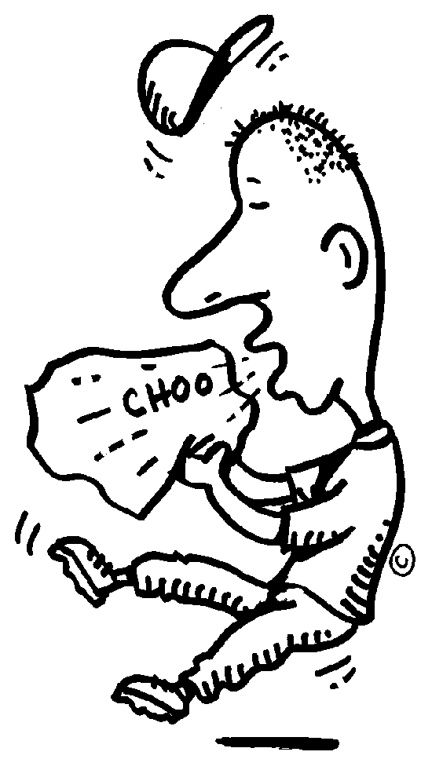
ILLNESS

If your child has been ill with a cold, chicken pox, etc., be sure that he/she is completely recovered before sending him/her back to school. The students are not allowed to stay in their classrooms at recess or at lunch, as they would not be under teacher supervision. If they are not sufficiently recovered, they should not be sent to school.

MEDICATION ON CAMPUS

For the administration of medication to other students during school or school-related activities, the Superintendent or designee shall develop protocols which shall include options for allowing a parent/guardian to administer medication to his/her child at school, designate other individuals to do so on his/her behalf, and, with the child's authorized health care provider's approval, request the district's permission for his/her child to self-administer a medication or self-monitor and/or self-test for a medical condition. Such processes shall be implemented in a manner that preserves campus security, minimizes instructional interruptions, and promotes student safety and privacy.

OBSERVER RULES OF ETIQUETTE IN THE CLASSROOM

We are happy to have you observe in the classroom and would like you to follow these procedures:

  - Please call ahead of time and make an appointment to meet with the principal. This will assure that you will be able to observe the activities that are of interest to you.
  - Sign in at the office. You will be given a Roseville City School District visitor pass to wear during your visit.
  - Sit in the back of the room in order that the children’s attention is not diverted.
  - Do not talk to the teacher during the period class is in session. If you have questions, please make an appointment to talk with the teacher after classes are

out of session.

CLASSROOM INTERRUPTIONS

It is our goal to reduce the number of interruptions to the instructional program; therefore, increase the amount of time on task for students.
Thanks!
You, as parents, can assist us in this by:
- Being aware of the importance of not losing instructional time.
- Not going to the classroom during instructional time to talk to the teacher.
- Arranging doctor and dental appointments so students can be picked up during recess or lunch breaks or after school.
- Knowing messages will not be delivered to the classroom, except in an emergency. They will be placed in the teacher’s box.
- Lunches, homework, etc., will not be delivered to the classroom. They may be placed on the office counter. Please be sure to tell your child to check in the office if they need any of these items. It is their responsibility.
- Balloons, flowers and other gifts for students may not be received in the classroom.
- Timing your arrival to visit a classroom before instruction begins at 8:49 am. or during a recess break.
- Informing your own children that they do not have the right to interrupt the teaching/learning process with misbehavior.

POSITIVE BEHAVIOR INTERVENTION SUPPORT SYSTEM

* Respect Yourself, Respect Others, and Respect Property
* Be Safe, Be Responsible, Be Respectful
* Respect Relationships and Respect Responsibilities

Posted around school you will see our behavior expectations. We will focus on the positive with more attention on what the student doing that is safe, kind, respectful and responsible.

PLAYGROUND RULES

To make the playground a safe and pleasant place for everyone, the general rules and consequences are as follows:
    - No fighting or rough housing
    - No talking back or disobeying staff
    - No misuse of play equipment or interrupting other people=s games
    - No destroying school property
    - Walk to and from the building and line up in orderly manner
    - Stay out of unauthorized areas
    - Severe clause - willfully:
-destroy property
-disobey adult personnel
-inflict harm on any person

Students will be informed of specific rules for the various playground apparatus by their teachers.

CONSEQUENCES AND REWARDS

Documentation of inappropriate behavior will occur and consequences will be enforced. Students displaying positive behavior have the opportunity to receive recognition in a variety of ways.

GUIDELINES AND PROCEDURES FOR CRESTMONT SCHOOL PUPILS

In the classroom:
1. Children are expected to enter and leave classrooms in an orderly manner in compliance with specific rules established by the classroom teacher.
- Children are expected to act in a non-disruptive manner showing respect to the teacher and other classmates.
- Children are expected to be knowledgeable of and comply with all classroom rules in order to create an atmosphere conducive to learning.

- Children are expected to keep desks clean - - free from writing, marking, and decals.
- Children and parents are responsible for all texts, library books, and other materials loaned to pupils.

On school premises:
- For safety purposes, footwear appropriate for physical education and recess
playtime should be worn. Flip flops are NOT allowed. Sandals must include a strap around the back. (We encourage wearing socks also for safety reasons).
- Children are to play in designated areas only.
- Office areas, teacher’s rooms, supply rooms, custodial rooms, and cafeteria are off limits to ALL children, unless specifically requested to be in one of those areas.
- Entry to the school area shall be made by entering through the gates - - not through the office.
- All children are to be outside when school is not in session, weather permitting.
- Children riding bicycles:

a. Enter grounds at entry nearest bicycle rack - - walk the bike

b. Place bike in rack.

c. Lock bike if you value it.

d. Bikes may not be locked together.

e. Follow bicycle safety rules and bicycle routes.
- Bicycles are not to be ridden on the playground or any other school area.
- Rollerblades, skateboards and skate shoes are not permitted on school grounds.
- School corridors will not be used for play areas at any time.
- Students may not leave the school premises during the school day without parental checkout.
- School telephones are for business purposes only. When an emergency arises, students may request permission to use the telephone.
- Bell schedules are to be strictly adhered to. Children are to stop playing at the bell and return to classrooms in an orderly manner.
- iPods, MP3 players and other electronic items/games are the responsibility of each student. Crestmont School is not responsible for any lost items.
- Fighting, sparring, wrestling, whether in anger or in play, is not permissible.
- Vulgar or profane language spoken, written, or gestures will not be accepted.
- Any type of behavior that may endanger the health, welfare, or well-being of another person, will not be accepted.
- Knives, or any other objects that may be used as weapons, are not to be brought on campus. Having any of these objects will result in suspension and could result in expulsion from the district.

LOST AND FOUND
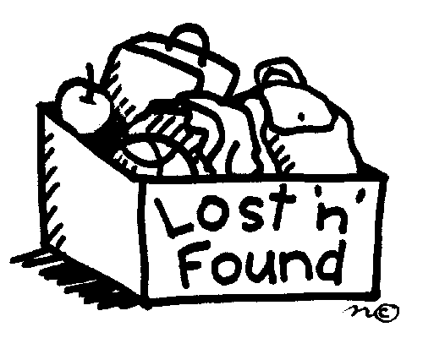
Please make sure that jackets, sweaters, etc., are well marked with child’s name and phone number. We accumulate a vast assortment of items that end up in our lost and found, because they have no name
on them. Items that are left are donated to charity during Winter break and at the end of the school year.

BICYCLE & SCOOTER SECURITY
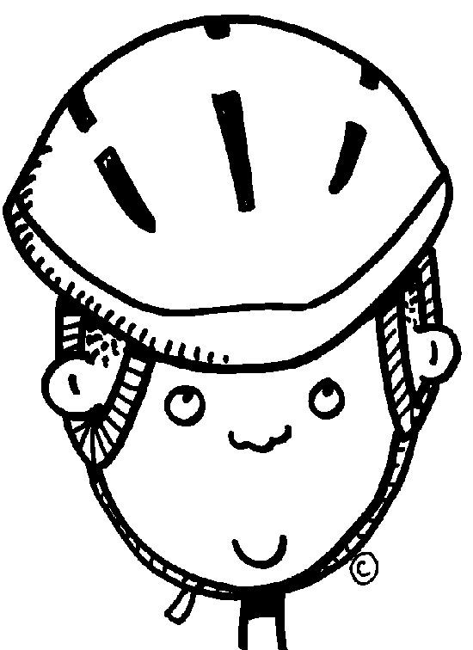
If your child uses the bicycle racks, we encourage the students to lock up their bicycle or scooter.

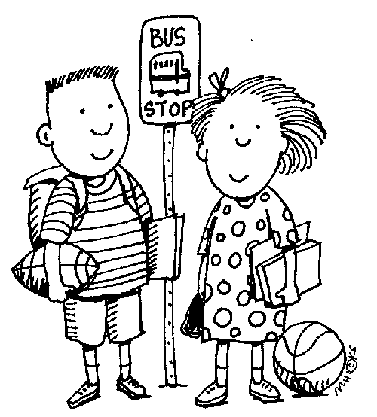
SAFE ROUTE TO SCHOOL

Parents, please instruct your children about the rules of safety to be used when walking or biking to and from school.

All students walking to school are directed to use the sidewalks, whenever possible. Caution should be used in crossing streets, and the use of crosswalks and signals is recommended where available. Please caution your children to be especially careful when crossing in this area.

Students walking down Cirby Way should take Vista Creek Drive as a route to Crestmont. The reason for this is that the entrances to Oakmont High School are heavily traveled, and drivers may not be looking out for elementary-aged students.

Please walk your bike or scooter when you are on the school grounds.

CELL PHONES

Cell phones need to be kept in backpacks at all times during school hours, so they are not a distraction to the learning environment.

STUDENT DRESS CODE

Appropriate footwear must be worn at all times. Flip flops are not allowed. Clothing, jewelry, and personal items shall be free of writing, pictures or any other insignia which are crude, vulgar, violent, gang related, profane or sexually suggestive, which bear drug, alcohol or tobacco company advertising, promotions and likeness, or which advocate radical ethnic or religious prejudice. Clothing must be appropriate and sufficient to conceal undergarments at all times. No spaghetti strap tops, see-through or fish-net fabrics, halter-tops, off-the-shoulder or low-cut tops, bare midriff, tight shorts, and very short skirts or shorts are prohibited. Hair shall be cleaned and neatly groomed. Hair may not be sprayed with any color that would drip when wet. Hats, hoods, or head coverings cannot be worn in the classroom.

LATE PICK-UP

School staff are on duty for 15 minutes after school. You must come into the office to sign your child out if you are more than 15 minutes late – for safety reasons please be sure you make arrangements for your child to be cared for after school. Continued practice of parents arriving late to pick up students may result in referral to CPS.

