Kaseberg
5th Grade

Date: Week of Feb. 19, 2019
Mr. Tapia: STapia@rcsdk8.org
Mrs. Adams: TAdams@rcsdk8.org

Mojo of the Week room 16  Congratulations to Tyler Cole! He has shown growth mindset by working hard everyday and improving his I-Ready scores in reading. Tyler has been giving his best effort during testing and growing each time we test. Keep up the great effort in class!  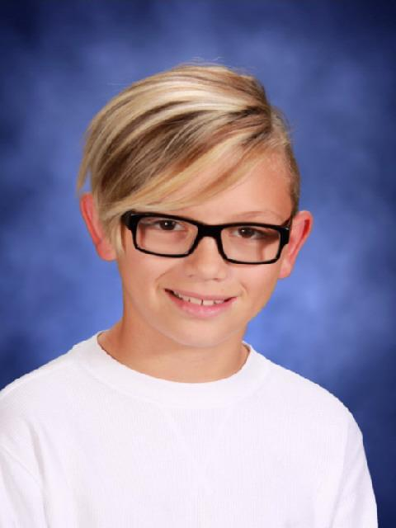 | Mojo of the Week room 17  Congratulations to Lila Jones. She shows that she is eager to learn in all areas. She is writing a multi-chapter novel, gives me fun facts and clearly explains her math, volunteers information and ideas all the time...she makes teaching fun!  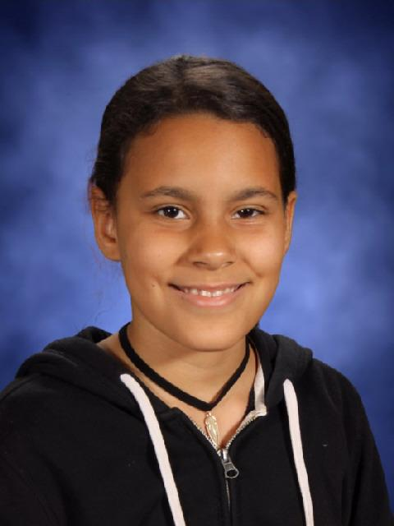

Standards being taught:
Reading: We are finishing up with informational text around the topic of the US Constitution.
RI4-determine the meaning of academic words and phrases
RI5-compare structure and ideas/events/concepts etc. over two or more texts
RI6-analyze multiple accounts of the same event or topic
Writing: We are learning about ways to generate ideas for informational writing.
Social studies: We are reading about the constitution and amendments.
Science: Life science! We have been studying decomposers and learning interesting things!
Math: We are multiplying decimals and will be reviewing how to divide whole numbers.
Ways you can help your child at home:
-Work with your child to do a little research about a topic they think they would like to write about.
-Go through their binder with them. They need help keeping cleaned up and organized.

Please note...testing starts in April, and practice tests precede that. Students need headphones for their tests! Please have them keep an inexpensive pair in their backpack for use at school. Thanks!

Dates to remember:
Box Tops collection is under way! Proceeds to benefit Placer County foster children.
Feb. 20-family life. PERMISSION FORM NEEDED
Feb. 22-zumba breakfast; PTC family dance
Feb. 25-fire safety assembly
Feb. 26-March 1-BLOW OUT book sale by student council. Proceeds to purchase life straws for those with unclean water.
March 1-read across Kaseberg; citizenship day

