Kaseberg
5th Grade

Date: Week of Nov. 13, 2018
Mr. Tapia: STapia@rcsdk8.org
Mrs. Adams: TAdams@rcsdk8.org

Mojo of the Week room 16  Congratulations to Guillermo Hernandez! He has shown growth mindset by staying on task and always being prepared. Guillermo consistently stays on task to ensure he learns everything from each lesson, and he is always ready with what he needs. Keep up the great effort in class! | Mojo of the Week room 17  Congratulations to Vincent Alvarez! Vincent showed a strong growth mindset during teacher/student conferences. He was honest and specific about what he is doing now, and ways to move forward.  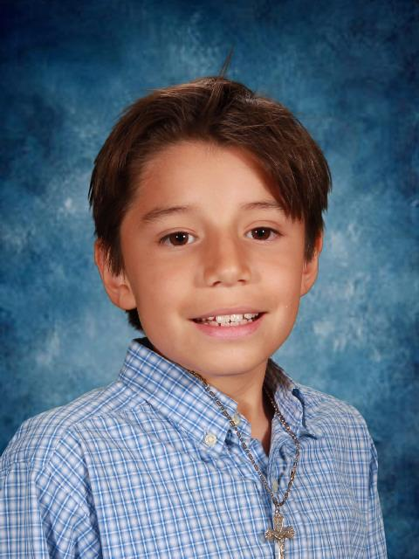

Standards being taught:
Reading: RI1-Quote accurately, RI2-determine main idea and support with details; summarize, RI3-explain relationships between events/ideas/etc.
Writing: Plan and Organize a narrative-we will be writing tall tales
Social studies: on hold
Science: We will be learning about chemical properties (vs. physical properties) and chemical change (vs. physical change). As we do this, we are also examining how context clues and text features help us to make meaning of informational texts.
Math: Decimals decimals decimals! We will continue reading/writing/comparing decimals and focus on place shifting by x and dividing by factors/multiples of ten. We will also move into rounding decimals.
Ways you can help your child at home:
-look at their check ins with them
-help them keep their folder organized. This is a skill that takes guided practice!
Dates to remember:
Nov. 14: school performance of musical
Nov. 15: night performance of musical
Nov. 19-23: Thanksgiving vacation
Nov. 30: Santa’s Helpers

