Kaseberg
5th Grade

Date: Week of Dec. 10, 2018
Mr. Tapia: STapia@rcsdk8.org
Mrs. Adams: TAdams@rcsdk8.org

Mojo of the Week room 16  Congratulations to Azucena Manuel! She has shown growth mindset by staying on task and giving 5th grade effort. Azucena has been giving her best effort to ensure she gets better each day in class. Keep up the great effort in class!  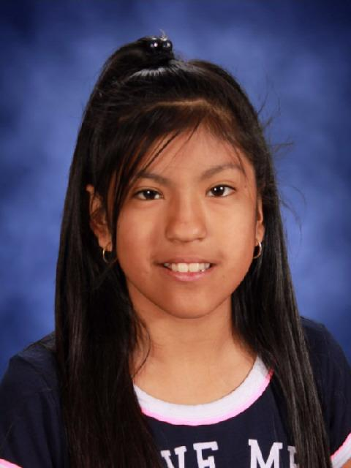 | Mojo of the Week room 17  Congratulations to Ben Verduzco! He has shown growth mindset over the last two weeks by being on task and on topic. He has also been polite and working with other students to accomplish tasks.  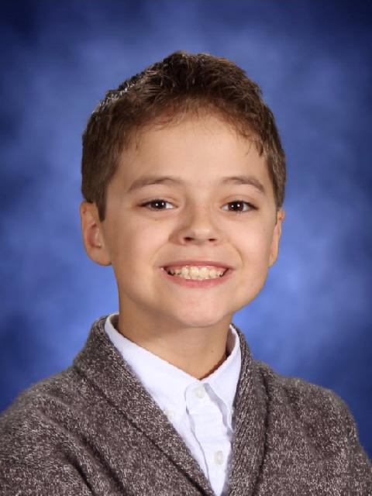

Standards being taught:
Reading: We are moving into literature. The first 3 reading standards are similar to those of informational text. RI1-Quote accurately, RI2-determine theme and support with details; summarize, RI3-compare/contrast characters, settings, etc.
Writing: We are learning about the structure for writer’s workshop.
Social studies: on hold
Science: We will be moving into life science! Students are considering what they would need (food wise) to survive in a biosphere.
Math: multiplication and division of fractions!
Ways you can help your child at home:
-start your child now with working on one of the web sites for multiplying fractions
-ask them about the biosphere
Dates to remember:
Dec. 14: buddiesDec. 19: SC
Dec. 20: choir performance
Dec. 21 MINI DAY, earned party room 17
Dec. 24: first day of winter break

