Kaseberg
5th Grade

Date: April 8, 2019
Mr. Tapia: STapia@rcsdk8.org
Mrs. Adams: TAdams@rcsdk8.org

Mojo of the Week room 16  Congratulations to John Hepper! He has shown growth mindset by collaborating with his classmates. J.J. works hard each day to stay on task, but he makes an effort to ensure his peers are working as well. Keep up the great effort in class!  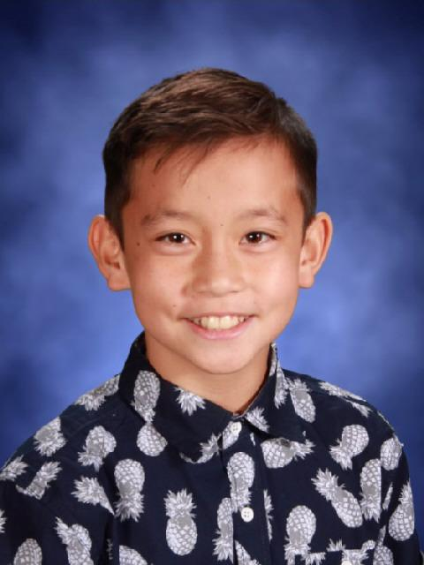 | Mojo of the Week room 17  Congratulations to Leo Huerta-Cuevas. He is an “always” student and person. He is always ready and eager to learn, taking the time to double check his work and make correction, helpful and kind to others.  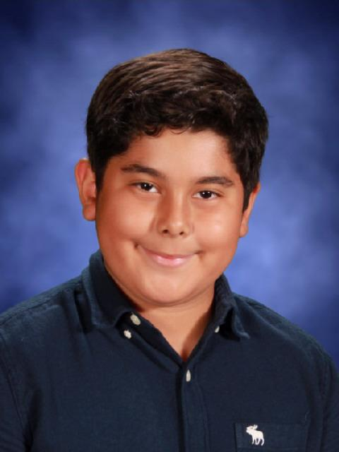

Standards being taught:
Reading: We are reading stories about America and analyzing them to understand the author’s point of view, how the author shows his/her point of view, and how that affects us, the reader.
RI4-determine the meaning of academic words and phrases
RI5-compare structure and ideas/events/concepts etc. over two or more texts
RI6-analyze multiple accounts of the same event or topic
Writing: We are learning how to write leads (grabber and claim), state reasons, and support with evidence in opinion writing.
Social studies:
Science: earth science begins...
Math: We are finishing up volume and reviewing for the CAASPP
Ways you can help your child at home:
-Make sure they are well rested, have a healthy breakfast, and attend on time each day during testing.
-Encourage your child to give reasons for their opinions.
Dates to remember:
4-11: mini day; open house 6-7
4-12: egg drop with buddies; end box tops; variety aps due; inanimate object dress up day
4-15: spring break begins
4-23: return from spring break; TESTING BEGINS; room 17 party; otter pops out for box tops; try out information for variety show goes out.
4-24: TESTING; Sami Circuit
4-25: TESTING; awards for citizenship
4-26: TESTING
4-29: TESTING; variety show tryouts begin
4-30: TESTING
5-1: TESTiNG; school musical
5-2: TESTING; family musical
5-3: TESTING

