Kaseberg
5th Grade

Date: Week of Feb. 12, 2019
Mr. Tapia: STapia@rcsdk8.org
Mrs. Adams: TAdams@rcsdk8.org

Mojo of the Week room 16  Congratulations to Aaliyah Bradford! She has shown growth mindset by working hard everyday and staying on task. Aaliyah has been giving her best effort in class to ensure she gets better each day in class. Keep up the great effort in class!  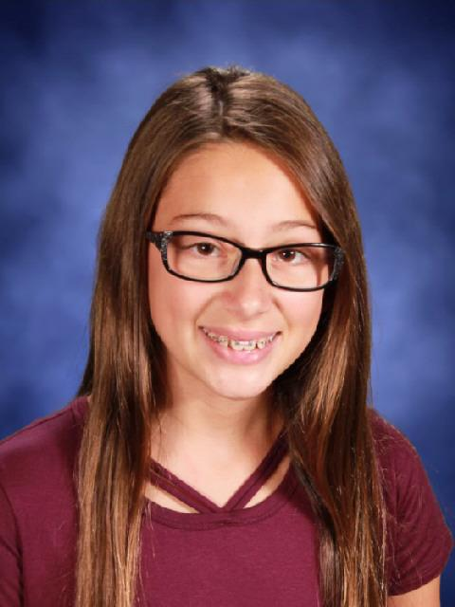 | Mojo of the Week room 17  Congratulations to Lila Jones. She shows that she is eager to learn in all areas. She is writing a multi-chapter novel, gives me fun facts and clearly explains her math, volunteers information and ideas all the time...she makes teaching fun!  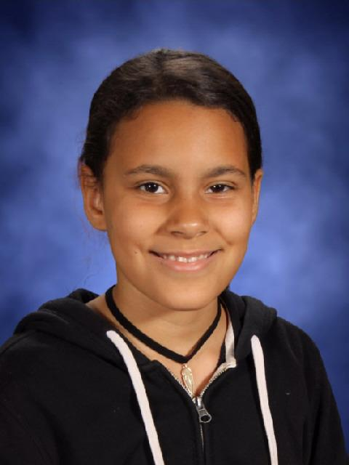

Standards being taught:
Reading: We are moving back into informational text and switching into reading standards 4, 5, and 6.
RI4-determine the meaning of academic words and phrases
RI5-compare structure and ideas/events/concepts etc. over two or more texts
RI6-analyze multiple accounts of the same event or topic
Writing: We are ending our first study of narrative writing. Student shared this week. Next we will be moving into informational text.
Social studies: We are reading about the constitution and amendments.
Science: Life science! Our foods are molding nicely now!
Math: We are multiplying decimals and will be reviewing how to divide whole numbers.
Ways you can help your child at home:
-Ask your child to share what they did in class. They can tell you about what is molding the fastest and why, or maybe they can tell you how many amendments there are around voting.
-Encourage your child to teach you something each day such as why the decimal goes where it goes when multiplying.
-Go through their binder with them. They need help keeping cleaned up and organized.

Please note...testing starts in April, and practice tests precede that. Students need headphones for their tests! Please have them keep an inexpensive pair in their backpack for use at school. Thanks!

Dates to remember:
Box Tops collection is under way! Proceeds to benefit Placer County foster children.
Feb. 14-room 17 party
Feb. 18-no school
Feb. 20-family life. PERMISSION FORM NEEDED
Feb. 22-zumba breakfast; PTC family dance
Feb. 25-fire safety assembly
Feb. 26-March 1-BLOW OUT book sale by student council. Proceeds to purchase life straws for those with unclean water.
March 1-read across Kaseberg; citizenship day

