Amazon Business Acceptable Use Policy

What am I able to purchase on Amazon Business?
From books to scientific lab supplies and everything in between, the Amazon Business Marketplace is our preferred destination for all non-catalog purchases. Please shop Amazon Business first when shopping for non-catalog products.

These categories have been approved district wide for non-catalog purchases through Amazon Business:

Books | Home and Kitchen
Office Supplies | Musical Instruments
Classroom, School, Art Supplies and materials | Animal Supplies, Equipment and Food
Scientific Equipment and Lab Supplies | Clothing and Uniforms
Miscellaneous, Hard to Find Items

Watch this video to learn how to optimize your Amazon Business shopping experience.

What items are restricted on Amazon Business?
Roseville City School District kindly asks that you continue to follow all existing purchasing policies related to items already on contract with the District. To help identify if an item does not comply with the District’s purchasing policies, you will see restricted messaging on the product detail page and business order information page. *Please note, if you would like to purchase an item that is labeled RESTRICTED, please contact your Purchasing Department for approval.

Can I use the Roseville City School District Central Amazon Business account for personal use?
The central Amazon Business Account must be used for business purchases only, in accordance with our purchasing policies. The Roseville City School District purchasing team will have access to all purchasing history made through the centralized Amazon Business account.

Activating your Amazon Business account

How do I create my Amazon Business account?
Access Amazon Business by clicking the link directly from the activation email you receive. The activation email will look similar to the one below, the subject line is “Welcome to Amazon Business”. The first time you access Amazon Business, you will be prompted to create an Amazon Business account. Use your @rcsd8.org email address and enter a password.
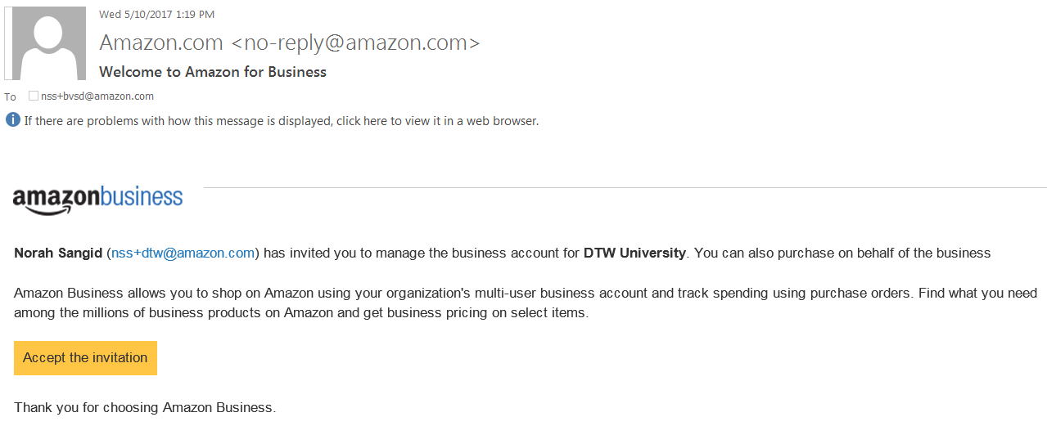

I already use my @rcsd8.org email address to make PERSONAL Amazon.com purchases.
If your @rcsd.org email address is already associated with an Amazon.com account, you will have the option to split off and transfer any purchase history to a separate account. You will be prompted to enter a new, personal, email address (e.g. gmail.com or Hotmail.com).

When I click Accept the Invite in the activation email, I am prompted to log in. I do not know my log in credentials.
You are asked to log in when you click the link in the activation email because you have an existing account with Amazon. If you do not remember your Password, please call Customer Service and ask for a link to reset your Password. Customer Service can be reached at 866-486-2360.

I previously used my @rcsd8.org email address to register for a verified Amazon Business account.
If you previously used your @rcsd.org email address to register for a verified Roseville School District Amazon Business account, you will need to de-register that account. All previous, stand-alone, Amazon Business accounts will be consolidated under the new, centralized account. Visit https://amazon.com/gp/b2b/manage/deregister to complete the de-registration process before accessing Amazon Business for the first time.

Ordering and Returning Items

What do I do if my order is rejected?
If your order is rejected through the approval process, please talk with your department/school administrative assistant to discuss and re-order if necessary.

How do I return or exchange an item?
To return or exchange an item, hover over (User)’s Account for Business Orders to view your complete order history.
  - Select Return or Replace items at right of product image
  - Select reason for return
  - Print label and authorization
  - Prepare package and return label
  - Complete the RCSD Merchandise Return to Vendor form
  - Provide package and Merchandise Return to Vendor form to your admin assistant
Items shipped and sold by Amazon.com orders can be returned within 30 days or receipt of shipment.
If shipped and sold by a 3rd party, policies can vary. If you have questions you can contact the Amazon Business customer service team.

Amazon Business Customer Service

How do I contact Amazon Business Customer Service?
Amazon Business Customer Service is available seven days a week from 5 am to 9 pm PST.

The Contact Us link is available at the bottom of every Amazon webpage (Let Us Help You > Contact Us) and provides Live Chat, Self-Service options, and requires no additional business account authentication.

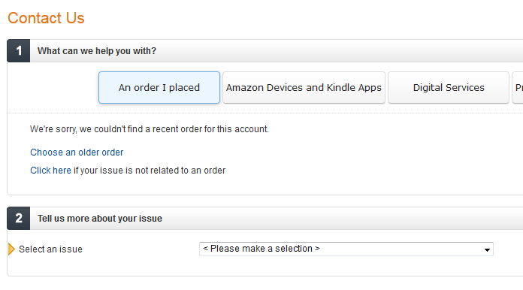

Amazon Business Customer Service can also be reached at 866.486.2360. Calling Customer Service may require account validation with School District billing address.

