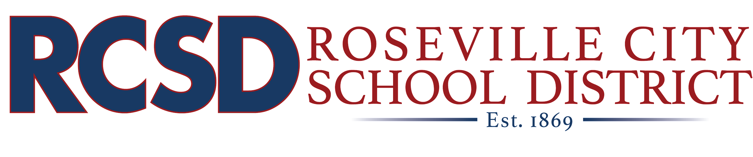

2021-22 School Year
COVID-19 Close Contact FAQs
August 20, 2021

The below information provides answers to Frequently Asked Questions (FAQs) related to COVID-19 protocols in the Roseville City School District (RCSD) if your student has been identified as a close contact to someone positive for COVID-19. RCSD will update the information as it becomes available.

FOR IN-SCHOOL EXPOSURE ONLY

- My student has been identified as a close contact with someone in their class(es). They are asymptomatic, are they required to quarantine?
Your child may continue to attend in-person school under a modified quarantine if all of the following are true. Your child:
- Remains free of COVID-19 like symptoms;
- Continues to comply with the required masking policy;
- Has a parent/guardian self attest to have the student undergo testing two times during the modified 10-day quarantine; and
- Quarantines for extracurricular activities at school and activities with the community setting.

- My student is fully vaccinated*. Do they still need to quarantine if they are asymptomatic but identified as a close contact?
If all of the following are true, your child may remain at school and continue participating in extracurricular activities (e.g., sports, clubs, etc.). They are:
- Fully vaccinated;
- Have shared their vaccination card with school staff for verification; and
- Remain free of COVID-19 like symptoms (asymptomatic).

- My student is fully vaccinated*. Do they need to test prior to returning to school after being identified as a close contact?
No. Your student does not need to test before returning to school. However, if your child becomes ill within 14 days of their last exposure to the positive case, they must immediately stay home to isolate, get tested for COVID-19, and adhere to the directions of your healthcare provider.

- My child has been identified as a close contact at school with a COVID-positive individual, and I would prefer my child stay home for the 10-day quarantine period. They are asymptomatic; however, I would like to take precautionary measures. Can my child still get their school work?
Yes. If your child has been identified as a close contact you may keep them home for the entire identified 10-day quarantine period provided in your contact letter. If you keep your child home due to a school-related close contact, you may contact the office to sign up for a short-term independent study.

- My child is under a modified quarantine due to a close contact at school. What am I required to provide the district to indicate I have had my child tested twice during the 10-day quarantine period?
RCSD requires that parents self-attest that they had their child tested twice during the 10-day quarantine period and are not required to provide documentation at this time.

- My unvaccinated child has already tested positive for COVID in the past 90 days but is currently negative. What, if any, quarantine requirements must they adhere to after being a close contact with a currently COVID-positive individual?
For unvaccinated students who have tested positive for COVID in the past 90 days and are currently negative, please contact the school for further information and direction related to quarantine.

FOR AT-HOME EXPOSURE
- My student lives with someone who just tested positive for COVID. My student is unvaccinated but asymptomatic. May they still come to school under the modified quarantine?
No. If your student lives with someone who has tested positive and is therefore in contact with that individual every day, they must quarantine and cannot come to school during the quarantine period.

- How long is the quarantine for my unvaccinated student living with someone that is COVID positive?
A student’s quarantine that is living with someone who is COVID positive cannot start until after the positive individual’s isolation period ends (typically ten days from the time of symptom onset and/or positive test). Once a student’s quarantine period begins, and if they remain asymptomatic, the student may test on Day 5 of quarantine. If they show a negative test, they may return to in-person instruction on Day 7.

- Is there any way my unvaccinated student may still attend in-person school under the modified quarantine if they are asymptomatic but live with someone COVID positive?
If they are able to find care in another virus-free home isolated from the COVID-positive individual (i.e., with a close relative, grandparent, etc.), the child’s quarantine period begins on the day in which they start that care in the virus-free home. If the child then remains asymptomatic, they may test on Day 5 of quarantine, and if they receive a negative test may return to in-person instruction on Day 7.

- My student is living with someone that tested positive for COVID but is fully vaccinated*. What are he/she’s quarantine requirements?
Students that are fully vaccinated are not required to quarantine and may continue to come to in-person classes; if all of the following are true, they:
- Are asymptomatic;
- Continue wearing a mask; and
- Have shared their vaccination card with school staff for verification.
However, if your student becomes ill within 14 days of their last exposure to the positive case, they must immediately stay home to isolate, get tested for COVID-19, and adhere to the directions of your healthcare provider.

- My child is being quarantined due to a close contact with a COVID-positive individual at home. Can my child still receive schoolwork while they are out of school?
Yes. Your child will be given an excused absence for the duration of time in which they must remain quarantined due to a close contact at home. Please contact your child’s teacher(s) directly, and they will assign them work.

*Fully vaccinated is 2 weeks after the individual’s second dose in a 2-dose series or a single-dose vaccine.

