ROBERT C. COOLEY MIDDLE SCHOOL
SHOWCASE NIGHT
FOR ALL 5TH GRADERS AND THEIR PARENTS

TUESDAY, JANUARY 22, 2019
6:00 – 6:30 PM – LAST NAMES A – L
6:30 – 7:00 PM – LAST NAMES M - Z

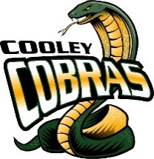

GO COBRAS!!
9300 PRAIRIE WOODS WAY, ROSEVILLE CA 95747

