QUESTIONS VOLLEYBALL STUDY GUIDE
1. Volleyball was invented in what year?_________  2. Who invented Volleyball?_____  ______________  3. How many players on a regulation Volleyball team?____  4. How many points does your team need to win?___________  5. What position serves first?_______  6. Can the ball hit the net?________  7. Can a player touch the net?  ______________  8. What is the ideal offensive attack?  _________________  _________________  9. What Volleyball skill do you want to use as the second hit?_____________  10. What is the hit called that hits the ball downward?  _________________  11. Where do you want the ball to contact your arms when doing a forearm/bump pass?  _________________  12. Does a block count as a hit?  _________________  13. Can a player hit a ball twice in a row?  _______________  14. How many hits does each team have to get the ball over the net?  _________________  15. If a ball hits the line is that IN or OUT?____________  16. What is a serving foot fault?  ___________________  ___________________  17. Name two rules we changed for PE games.  a._________________  B. ________________  18. List two ways to have good sportsmanship during a volleyball game.  a. _________________  b. _________________ | HISTORY:  Volleyball was developed in 1895 by William G. Morgan  at the YMCA in Holyoke, Massachusetts. It was developed  for businessmen who required a game that involved less  physical contact than basketball. Volleyball was introduced  to the Olympic Games in Tokyo in 1964.  GAME:  Volleyball is a game played by two teams of 6 players separated by a net. Volleyball positions are set up with 3 front row players and 3 back row players. The object of the game is to send the ball over the net so that the opposing team cannot return the ball. Games are played to 25 points with tie breaker games being played to 15 points. The winning team must win by two points. Rally scoring is used in Volleyball which means whenever a team wins a rally they will earn a point and the right to serve.  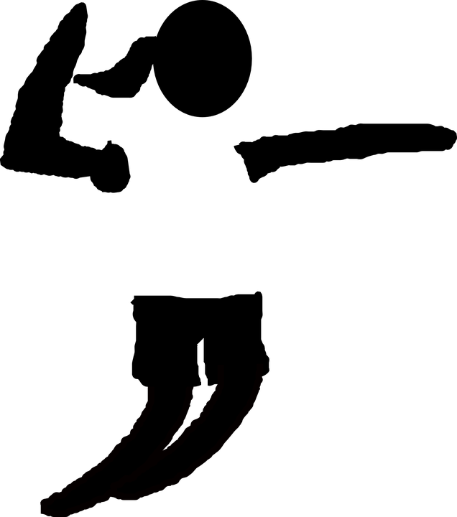  SERVING:  - The Right Back player starts the game with a serve. The serve may be overhand or underhand.  - The server must have both feet behind the end line or else it will be a foot fault.  - Rotate positions in a clockwise pattern when it is time for your team to serve.  - The ball MAY touch the net on a serve.  SKILLS IN VOLLEYBALL  Forearm pass/Bump- Method of passing the ball by bouncing it simultaneously off of both forearms. Grip: thumbs parallel, arm extended/elbows straight: bend knees to get under ball; contact with forearms. The angle of your arms at contact of ball will determine the direction of the ball.  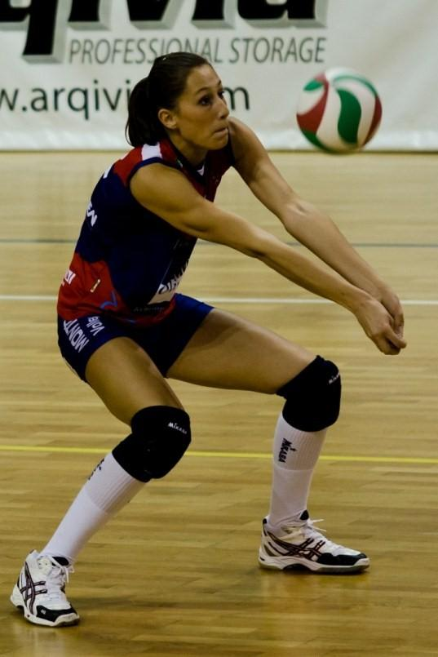  Overhead Pass/Set- Overhand technique of putting the ball into the air close to the net for the spike. Usually the second hit after the forearm pass. Get under the ball; hands above head with fingers spread, elbows out, contact the ball with all fingertips, extend arms after contact.  Spike/Hit- Striking of the ball with one (open palm) hand hit forcefully downward into the opponent’s court. This is the ideal third hit in a series.  “BUMP, SET, SPIKE” is the ideal offensive attack.  The spike/hit is an overhand hit like done with serving. It is also a similar motion like throwing a baseball overhand.  DIG- Passing of a powerfully spiked ball or hit. The back row players usually are responsible for digging the ball and keeping it in play.  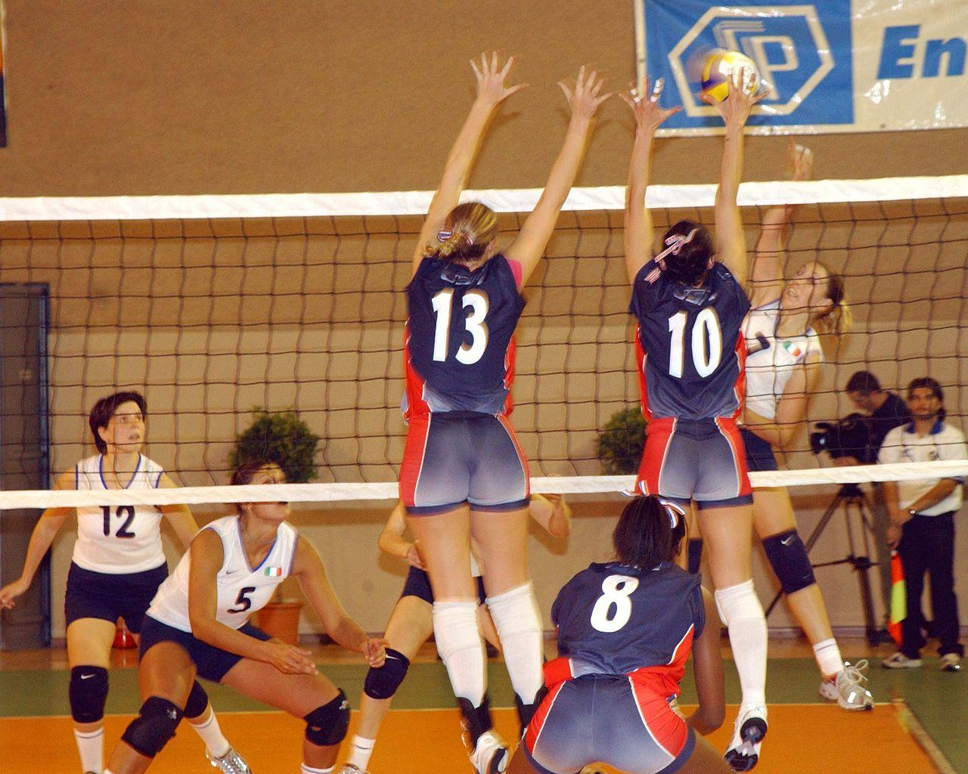  BLOCK- A defensive play by one or more of the front row players meant to intercept a spiked ball. THE BLOCK DOES NOT COUNT AS A HIT.  Regulation Rules:  - Each team has three hits to attempt to get the ball over the net.  - A ball hitting a line is IN.  - Touching the net with any part of the body while the ball is in play is illegal and results in a point for the other team.  - A player may only hit the ball once in a row unless: the player blocks the ball or two players hit the ball at the same time.  - A player cannot step on the other side of the net.  PE Modifications used during some of the unit:  - Smaller courts  - Shorter nets  - May serve in front of end line.  - More than three hits per side.  - Ball may bounce in between passes.  Strategy  - Move feet and get behind the ball to make passes.  - Call for the ball and communicate with your teammates.  - Always display good sportsmanship (give compliments and encouragements).  Five ways to be a contributing team member for your volleyball team.  - Stay on task  - Do your share of the work  - Give compliments and encouragements  - Help others know and understand drills, game rules, and strategy.  - Know and follow the rules.  Class Conduct  - Never argue with a referee. Be fair and honest when making your own calls.  - Return ball to the server by rolling the ball back under the net directly to them.  - Do not kick or shoot hoops with the volleyball.  - Always announce the score before serving the ball.  - High 5 the other team at the end of the game.

